|  |  |
| --- | --- |
| **Ex. No. 3** | **Design a Web Page using HTML and CSS** |
| **Date of Exercise** | 02.08.2022 |
| **Web Host Link** | <https://jerryallwin.github.io/WEB-TECH/EX3/ex3page.html> |
| **Youtube Link** | <https://youtu.be/UxVCV1IjiP8> |

**Aim**

Create a web page for any institution or organization of your choice using HTML and CSS features that conform to the following guidelines.

**Description**

* External CSS

With an external style sheet, We can change the look of an entire website by changing just one file!

Each HTML page must include a reference to the external style sheet file inside the <link> element, inside the head section.

**Tags used**

* div

The <div> tag defines a division or a section in an HTML document.

The <div> tag is used as a container for HTML elements - which are then styled with CSS or manipulated with JavaScript.

The <div> tag is easily styled by using the class or id attribute.

* class

The HTML class attribute is used to specify a class for an HTML element.

The class attribute is often used to point to a class name in a style sheet. It can also be used by JavaScript to access and manipulate elements with thapecific class name.

* CSS class Selector

The class selector selects HTML elements with a specific class attribute.

To select elements with a specific class, write a period (.) character, followed by the class name.

* CSS Universal Selector

The universal selector (*) selects all HTML elements on the page.

# CSS Backgrounds

The background-colour property specifies the background color of an element.

* Opacity / Transparency

The opacity property specifies the opacity/transparency of an element. It can take a value from 0.0 - 1.0. The lower value, the more transparent

* CSS background-image

The background-image property specifies an image to use as the background of an element.

By default, the image is repeated so it covers the entire element.

* CSS background-repeat: no-repeat

Showing the background image only once is also specified by the background-repeat property:

* CSS Margins

The CSS margin properties are used to create space around elements outside any defined borders.

With CSS, you have full control over the margins. There are properties for setting the margin for each side of an element (top, right, bottom, and left).

CSS has properties for specifying the margin for each side of an element:

* margin-top
* margin-right
* margin-bottom
* margin-left

## CSS Padding

The CSS padding properties generate space around an element's content, inside any defined borders.

With CSS, you have full control over the padding. There are properties for setting the padding for each side of an element (top, right, bottom, and left).

CSS has properties for specifying the padding for each side of an element:

* padding-top
* padding-right
* padding-bottom
* padding-left

## CSS Setting height and width

The height and width properties are used to set the height and width of an element.

The height and width properties do not include padding, borders, or margins. It sets the height/width of the area inside the padding, border, and margin of the element.

## CSS Box Model

In CSS, the term "box model" is used when talking about design and layout.

The CSS box model is essentially a box that wraps around every HTML element. It consists of: margins, borders, padding, and the actual content.

## CSS Outline

An outline is a line that is drawn around elements, OUTSIDE the borders, to make the element "stand out".

# CSS Pseudo-classes

A pseudo-class is used to define a special state of an element.

For example, it can be used to:

* Style an element when a user mouses over it
* Style visited and unvisited links differently
* Style an element when it gets focus

## Input Fields

If we only want to style a specific input type, you can use attribute selectors:

* input[type=text] - will only select text fields
* input[type=password] - will only select password fields
* input[type=number] - will only select number fields

**Program**

**ex3page.html**

<!DOCTYPE html>

<html lang="en">

<head>

    <meta http-equiv="X-UA-Compatible" content="IE=edge">

    <meta name="viewport" content="width=device-width, initial-scale=1.0">

    <link rel="stylesheet" href="mystyle.css"

</head>

<body>

    <h1>Karunya Institute of Technology and Sciences</h1>

    <div class="banner"></div>

    <div class="about">

        <h3>About us</h3>

        <p>

            Karunya Institute of Technology and Sciences was founded with the noble vision to raise professionals and leaders of high academic calibre and unblemished character, nurtured with a strong motivation and commitment to serve humanity. The institution is the fulfillment of the vision of its founders Late Dr. D. G. S. Dhinakaran and the present Chancellor Dr. Paul Dhinakaran. Established in 1986 as an Engineering College, it was granted an autonomous status in 1999 and declared Deemed-to-be University by the University Grants Commission (UGC) in recognition of its academic excellence by the Ministry of Human Resources Development under section 3 of the UGC Act, 1956 vide notification no 9-3-2000-U3 dated 23.6.2004 of the Government of India. Accredited by NAAC, the institution offers a wide array of Bachelors, Masters and Doctoral Degree programmes in various branches of Engineering, Biotechnology, Food processing and Agricultural Sciences. From a humble beginning of 180 students, the institution has rapidly grown to 8491 students and 452 faculty representing 18 academic departments.

        </p>

    </div>

    <div class="box1">

        <h2>CSE</h2>

    </div>

    <div class="box2">

        <h2>Library</h2>

    </div>

    <div class="box3">

        <h2>CYBER SECURITY</h2>

    </div>

    <div class="box4">

        <h4>Campus life</h4>

        <p>Karunya is a residential institution, hosts diverse, creative and talented people from the state of India and from different parts of the world with a safe, secure environment and a plethora of student activities, the campus life at Karunya is vibrant, colourful, entertaining and engaging.</p>

    </div>

    <div class="box5">  </div>

    <div class="box6">

        <div class="form">

            <p>Sign In</p>

            <label for="">Username</label>

            <input type="text" placeholder="Enter Username / Email / Phone Number">

            <label for="">Password</label>

            <input type="password" placeholder="Enter Password">

            <input type="submit" value="Sign In">

        </div>

    </div>

    <div class="box7">

        <h4>Cyber Security Knowledge Mission</h4>

        <p>The pioneering technologies of internet of things, cloud storage, artificial intelligence and data science have made our dependence on the cyber world irreversible. This dependency on the cyber world has opened new avenues for data breach and has made the cyber world vulnerable to crimes and attack. KITS has launched this new mission to secure cyber space and monitor potential attacks by adopting essential technologies in building and protecting systems using cyber security tools with required automation, machine learning and threat intelligence.

        </p>

    </div>

</body>

</html>

**Mystyle.css**

*{

    margin: 0px;

}

h1{

    color:white;

    text-align: center;

    background-color: blue;

}

h2{

    color: rgb(12, 12, 24);

    text-align: center;

}

.banner{

    background-image: url("karunya.jpg");

    background-repeat: no-repeat;

    background-size: cover;

    border: 1px solid blue;

    width: 100%;

    height: 600px;

}

.about{

    background-color: bisque;

}

.about h3{

    color: rgb(12, 12, 24);

    text-align: center;

    font-size:  25px;

}

.about p{

    text-align: justify;

    padding: 14px;

    font-size: 18px;

}

.box1{

    height: 300px;

    width: 33.33%;

    background-image: url('cse.jpg');

    background-repeat: no-repeat;

    background-size: cover;

    float: left;

}

.box1 h2{

    background-color: black;

    color: white;

    padding: 10px;

    text-align: center;

    opacity: 0.5;

    position:relative;

    width: 100%;

}

.box1 h2:hover{

    opacity: 1;

}

.box2{

    height: 300px;

    width: 33.33%;

    background-image: url('library.jpg');

    background-repeat: no-repeat;

    background-size: cover;

    float: left;

    position: relative;

}

.box2 h2{

    background-color: black;

    color: white;

    padding: 10px;

    text-align: center;

    opacity: 0.5;

    position: absolute;

    width: 95.5%;

    bottom: 0px;

}

.box2 h2:hover{

    opacity: 1;

}

.box3{

    height: 300px;

    width: 33.33%;

    background-image: url('cyber.jpg');

    background-repeat: no-repeat;

    background-size: cover;

    float: left;

}

.box3 h2{

    background-color: black;

    color: white;

    padding: 10px;

    text-align: center;

    opacity: 0.5;

    position:justify-content;

    width: 96%;

}

.box3 h2:hover{

    opacity: 1;

}

.box4{

    width: 50%;

    height: 350px;

    float: left;

    background-color: bisque;

}

.box4 h4{

    font-size:  25px;

    width: 80%;

    margin-left: 80px;

    margin-top: 80px;

}

.box4 p{

    margin: 0 80px;

    margin-top: 10px;

    font-size: 20px;

    text-align: justify;

}

.box5{

    background-image: url("https://karunya.edu/sites/default/files/img/site/campus-life/front-campus-life-1.jpg");

    background-repeat: no-repeat;

    background-size: cover;

    width: 50%;

    height: 350px;

    float: left;

}

.box6{

    background-image: url("https://karunya.edu/sites/default/files/img/technology-mission/drone-for-agri.jpg");

    background-repeat: no-repeat;

    background-size: cover;

    width: 50%;

    height: 400px;

    float: left;

    display: flex;

    justify-content: center;

    align-items: center;

}

.box7{

    width: 50%;

    height: 400px;

    float: left;

    background-color: bisque;

}

.box7 h4{

    font-size:  25px;

    width: 80%;

    margin-left: 80px;

    margin-top: 80px;

}

.box7 p{

    margin: 0 80px;

    margin-top: 10px;

    font-size: 20px;

    text-align: justify;

}

.form{

    font-size: 20px;

    font-family: Arial, Helvetica, sans-serif;

    padding: 15px;

    width: 50%;

    height: 80%;

    background-color: white;

}

.form p{

    width: 100%;

    height: 60px;

    font-size: 30px;

    font-weight: bold;

    display: flex;

    justify-content: center;

}

.form label{

    width: 100%;

    height: 30px;

}

label,input{

    display: block;

}

input[type=text]{

    width: 93%;

    height: 26px;

    font-size: 18px;

    color: black;

    padding: 10px;

    border: 3px solid #b5b5b5;

    border-radius: 8px;

    margin-bottom: 5px;

    outline: none;

}

/* Pseudo class */

input[type=text]:focus{

    background-color: white;

    border: 3px solid #3675c8;

    box-shadow: 0 0 10px #5793db;

}

input[type=password]{

    width: 93%;

    height: 26px;

    font-size: 18px;

    color: black;

    padding: 10px;

    background-color: #d3d3d3;

    border: 3px solid #d3d3d3;

    border-radius: 5px;

    margin-bottom: 5px;

    outline: none;

}

/* Pseudo class */

input[type=password]:focus{

    background-color: white;

    border: 3px solid #3675c8;

    box-shadow: 0 0 10px #5793db;

}

input[type=submit]{

    width: 100%;

    height: 46px;

    font-size: 18px;

    background-color: #0166fe;

    border: 3px solid #0c5ccf;

    border-radius: 5px;

    margin-top: 45px;

    color: white;

}

**Output**

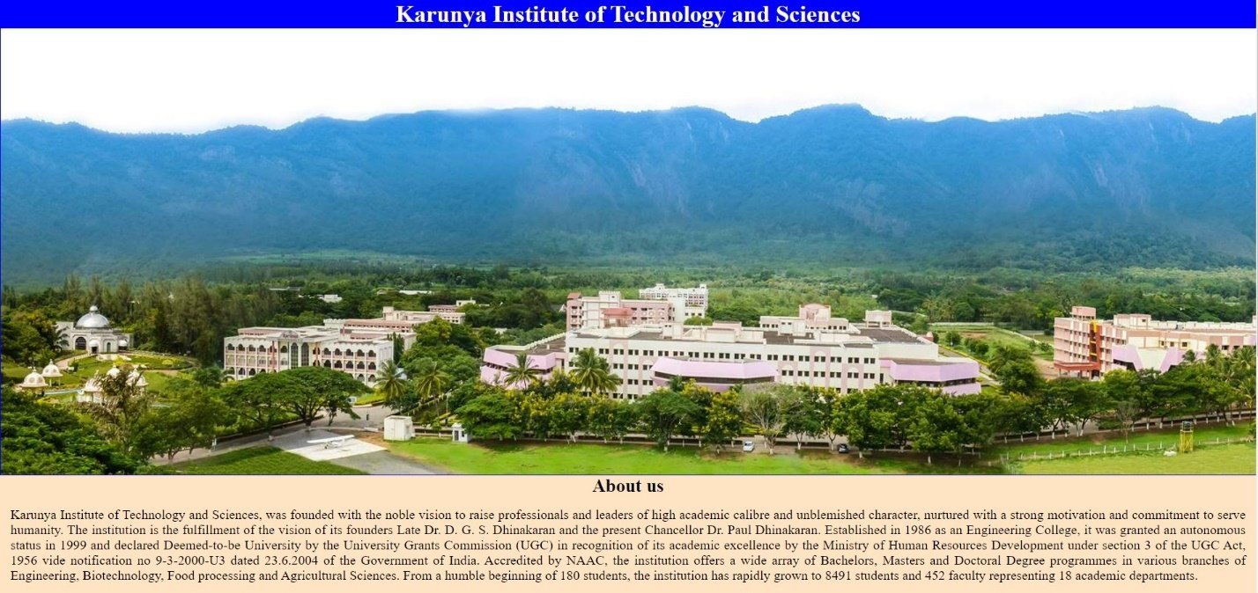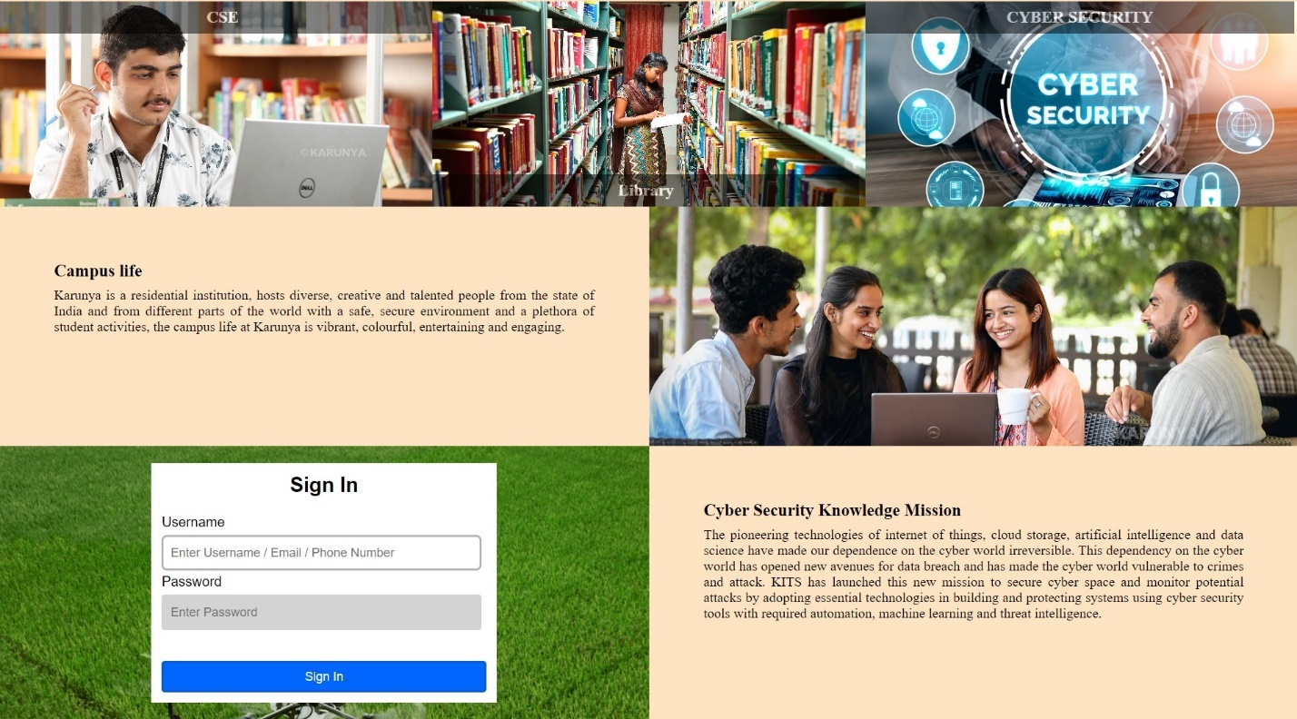

**Result**

The webpage has been designed and executed using HTML and CSS successfully.